**Introduction**

* The primary aim of this project is to track the bus location and monitor air pollution levels in the environment through a mobile application.
* When there is a bus failure on an ongoing journey, the passengers go into a dilemma whether to wait there for help to arrive or to move by private vehicle.
* Nowadays, the increase in harmful gases in the atmosphere is causing damage to human life.
* Through an android application, we can track the current status of the bus, monitoring the air pollution levels and updating the status of those to the nearest corresponding departments.

**Problem Statement**

The difficulties faced by people when a bus fails or one fails to board the bus on time lead to confusion among the people. Also air pollution is one of the major environmental issues that cannot be ignored. Inhaling pollutants for a long time causes damage to human health.

**Why and Who needs this**

* Imagine being able to track the location of your bus in real-time. With a bus tracking system, you can do just that! A bus tracking system can help our organization improve transportation efficiency and optimize routing. It can also help you track the whereabouts of buses and passengers in real-time, giving you complete visibility into your bus operations.
* The different areas have different levels of air quality at different times it is important for us to monitor what is happening. That way we can identify trouble spots and ensure that we are taking the right steps.
* The pollution levels in India increased in the year 2013 roughly 11 times higher than WHO guidelines.

**Aim/Objective**

**Aim:** The is to build an *"Android application"* which will help us track the bus locations and monitor the air pollution levels in the environment through a mobile application.

**Objective:** To provide the information and location of bus and amount of pollution during the journey of various places to the stake holders for taking care and prior precautions.

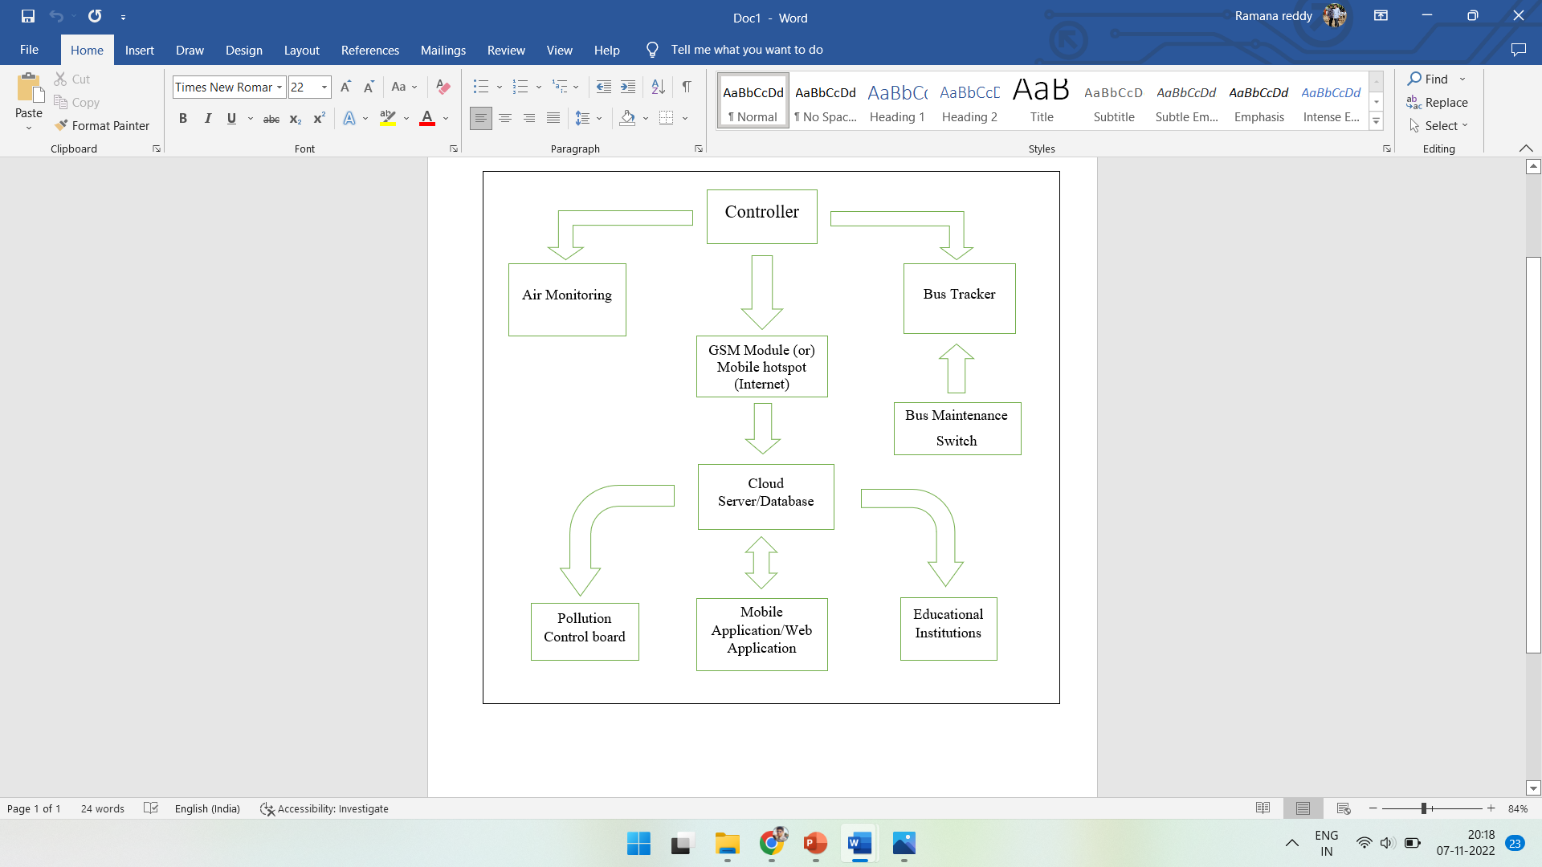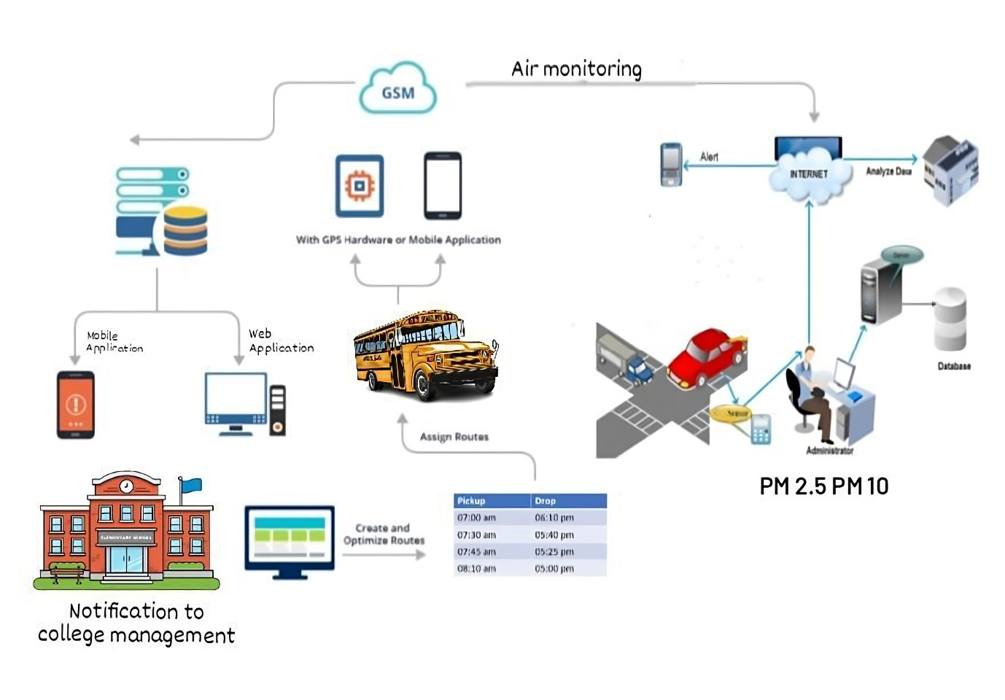

**Existing solution**

Both bus tracking & air pollution monitoring are already in existence, but in separate domain

**Our solution**

Here, both the specified applications will be existed in same domain

**User’s**

* Travelers
* Pollution control board

**End user**

* People who lives in urban areas
* Educational Institutions

**Stake holders**

* Pollution control board of Telangana
* Road Transportation corporation

**Importance to solve**

* Time Management
* To protect environment
* Health issues caused due to pollution